 

**CST3310 – Strategic Information Systems**

**(Enterprise Project) Management**Case Study: Emirates   
  
**Pair** CST33101 (1C)

|  |  |
| --- | --- |
| **Student Number** | **Student Name** |
| M00934348 | Fahad Khan |
| M00937253 | Naila Farooqi |



Submitted on: DD/MM/YYYY

Computer Science Department

Faculty of Science & Technology

Middlesex University

Table of Contents

0. Introduction 4

0.1 Introduction of your consultancy start-up 4

0.2 Presentation of each group member profile 4

0.3 Description of the selected Case Study organisation 4

7. Globalisation Issues (marketplaces / infrastructure / workforce) 5

7.1 Reflection on the organisation’s readiness for enter global markets 5

7.2 Evaluation of the organisation’s infrastructure maturity for globalisation 5

7.3 Review of how the organisation’s workforce would adapt to globalisation 5

8. Networking Issues (Social Networks / Wed 2.0 / IR 4.0) 6

8.1 Review of the organisation’s presence in social networks and media 6

8.2 Review of the organisation’s use of the Internet for business purposes 7

8.3 Review of the organisation’s practices aligned towards IR 4.0 8

9. Agile Approach to MIS 9

9.1 Overview of agile approaches in deployment of MIS 9

9.2 Introduction of an operational plan for transforming current practices 9

9.3 Description of measurable key performance indicators for the agile MIS approach 9

10. Impact of Information Systems on Society (ethics / privacy / security / CSR) 10

10.1 Reflection on the ethical impact of the organisation’s operations 10

10.2 Evaluation of the organisation’s current practices towards privacy / security / safety 11

10.3 Assessment of the organisation’s credo in relation to CSR 11

11. Intelligence and MIS (BI / AI / IE) 13

11.1 Evaluation of the organisation’s maturity to integrate Business Intelligence 13

11.2 Assessment of any opportunities for application of Artificial Intelligence solutions 13

11.3 Assessment of the organisation’s capacity to exploit Intelligent Environments 13

12. Conclusions 14

12.1 Summary of main suggestions for the organisation 14

12.2 Identification of main constraints in applying proposed plans 14

12.3 Reflection on lessons learnt for the members of the start-up 14

Appendix A – Interview questions 15

Appendix B – Individual reflection 16

Member 1 – M00934348 Fahad Ali Khan 16

Member 2 – M00937253 Naila Farooqi Baloch 17

Appendix C – Further evidence 18

References 19

# Introduction

Emirates is the world's largest international airline, flying to 158 destinations in 85 countries. Emirates operates 269 aircraft and is the world's largest operator of the Airbus A380 and Boeing 777 family of aircraft. Maintain international recognition as one of the leading aviation and security services business in the world, and set a benchmark within the industry.

## 0.1 Introduction of your consultancy start-up

## We are delighted to share the news that Emirates has selected our consulting firm, comprising a dedicated pair of advisors, to provide them with our expertise and guidance in enhancing their operations and strategic goals. Working alongside one of the world's premier airlines, we are thrilled to embark on this exciting partnership. Within our consultancy, our sole focus is on achieving exceptional outcomes and driving transformative change. We firmly believe that Emirates will continue to thrive, benefiting from our insights and innovative strategies.

## 0.2 Presentation of each group member profile

|  |  |  |  |  |  |  |
| --- | --- | --- | --- | --- | --- | --- |
| ID | Name | Sections | VARK | MBTI | PAEI | Belbin |
| M00934348 | Fahad Khan | 2, 3 | V | ESFJ | PaeI | Plant |
| M00937253 | Naila Farooqi | 2, 3 | V | ESFJ | PaeI | Plant |

## 0.3 Description of the selected Case Study organisation

## Emirates Airline, a major international airline with headquarters in Dubai, United Arab Emirates, is renowned for its exceptional customer service, broad network of routes, and dedication to innovation. In-depth analysis of Emirates' remarkable journey is provided in this case study, which also highlights the company's key operational best practices, key strategies, and other elements that have helped it succeed in the fiercely competitive airline sector.

## Background: Since it’s founding in 1985, Emirates Airline has developed into one of the top airlines in the world, flying to more than 160 locations on six continents. Its wide-body fleet of contemporary aircraft, which includes the recognizable Airbus A380 and Boeing 777, provides passengers with an opulent and comfortable traveling experience.

# Globalisation Issues (marketplaces / infrastructure / workforce)

# Globalization presents both opportunities and challenges for countries striving for financial stability, economic growth, and improved living standards. While each country's path to achieving these objectives may vary, several principles seem to underpin greater prosperity, including investment, technology diffusion, strong institutions, sound macroeconomic policies, education, and market economies. Participation in and integration with the global economy have been common factors in the success of high-growth countries. Evidence suggests that globalization can benefit citizens through increased access to goods and services, lower prices, job creation, improved health, and overall higher living standards.

# However, regional disparities persist, and poverty reduction efforts must continue. Risks associated with globalization, such as volatile capital movements, need to be managed, but they should not deter countries from embracing policy changes that build strong economies and a robust global financial system. The expansion of international trade, in particular, plays a crucial role in promoting efficiency, competitiveness, and economic resilience. Furthermore, the globalization of financial markets can attract investment, facilitate risk sharing, and foster economic growth. While debates exist regarding the impact of financial globalization, it remains an important driver of economic development and stability. Overall, embracing globalization and implementing supportive policies can help countries realize the benefits of greater integration with the global economy and uplift the well-being of their citizens. (IMF 2008)

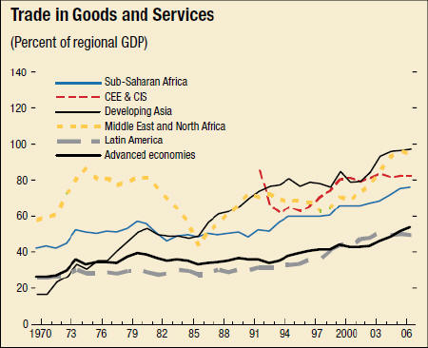

Figure 1 <https://www.imf.org/external/np/exr/ib/2008/053008.htm>

## 7.1 Reflection on the organisation’s readiness for enter global markets

Emirates airline is a well-established company that has achieved success in the global market. However, its vision is to become a world leader in the airline industry, which requires significant effort. In order to expand into international markets, Emirates needs a capable workforce that possesses the necessary skills, knowledge, experience, and understanding of organizational structure. With over 59,000 employees, Emirates has a strong foundation to enter any international market successfully. The CEO, managers, and operational experts at Emirates are highly qualified and experienced. To thrive in international business, Emirates recognizes the importance of understanding specific markets, maintaining a good portfolio, having a solid reputation, and being familiar with the dynamics of the industry. Additionally, the company has invested heavily in technology and support resources to facilitate its operations. With a team of over 3,000 engineers providing technical support and significant investments in software and hardware, Emirates ensures the smooth functioning of its operations. For instance, the recent installation of a $22 million connectivity system across its entire fleet showcases their commitment to enhancing their technological capabilities.

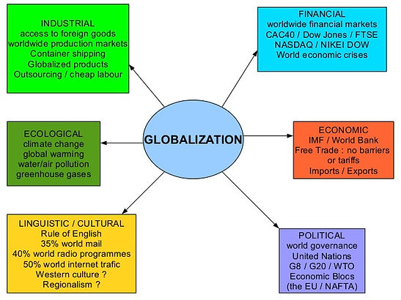

Figure 2 <https://www.julie-ingles.com/6-4>

When entering global markets, one crucial aspect to consider is the availability of financial resources. As a Dubai government-supported airline, Emirates has been profitable since its inception. In 2020, the company generated revenue exceeding $16 billion. With a presence in 157 destinations across more than 80 countries, Emirates possesses both the financial stability and expertise necessary for successful international flight operations.

## 7.2 Evaluation of the organisation’s infrastructure maturity for globalisation

Emirates has a strong foundation for expanding globally. While it may not be the top airline in every country, it is well-known and profitable in the Middle East region. The airline possesses a significant fleet size, with over 270 wide-body Airbus and Boeing aircraft. Its operations are based out of its own airport in Dubai, which serves both domestic and international flights. Emirates has established contracts with aircraft manufacturers to acquire new planes and employs thousands of engineers to handle technical issues. Notably, the company boasts 123 A380 planes, the largest commercial aircraft in the world.

Emirates has developed a robust online presence, with over 80 country-specific websites for online booking in addition to a global website. While the airline's infrastructure in Dubai is mature, it does not own airports in other countries. To become a top airline worldwide, Emirates would need to invest in infrastructure in other nations. Although the company generates substantial revenue, a significant portion of its aircraft is leased rather than owned.

## 7.3 Review of how the organisation’s workforce would adapt to globalisation

Emirates has a skilled and experienced workforce of over 59,000 employees, including qualified CEOs, managers, and operational experts (The Emirates Success Story, 2015). They possess the necessary skills and knowledge to handle international tasks and adapt to global markets.

With a fleet size of more than 270 wide-body aircraft, including the impressive A380 planes, Emirates has the capacity to operate globally (The Emirates Success Story, 2015). The company's investment in technology and support resources, coupled with a strong online presence, further enhances its ability to navigate international operations.

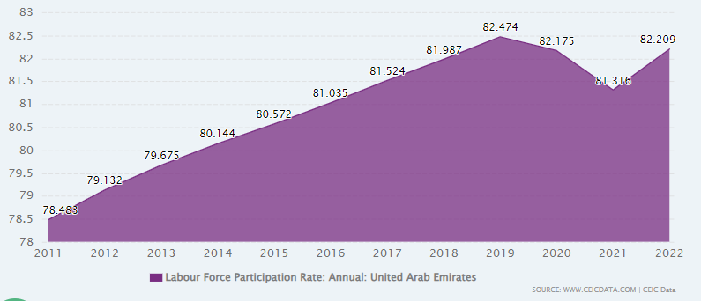

Figure 3 [https://www.ceicdata.com/en/indicator/united-arab-emirates/labour-force-participation-rate#:~:text=United%20Arab%20Emirates%20Labour%20Force%20Participation%20Rate%20increased%20to%2082.2,an%20average%20rate%20of%2076.5%20%25%20.](https://www.ceicdata.com/en/indicator/united-arab-emirates/labour-force-participation-rate%23:~:text=United%20Arab%20Emirates%20Labour%20Force%20Participation%20Rate%20increased%20to%2082.2,an%20average%20rate%20of%2076.5%20%25%20.)

Emirates' financial stability, supported by being a Dubai government-backed airline, provides a solid foundation for entering and thriving in global markets (The Emirates Success Story, 2015). Their commitment to understanding specific markets, maintaining a strong portfolio, and investing in infrastructure will contribute to their goal of becoming a top airline worldwide.

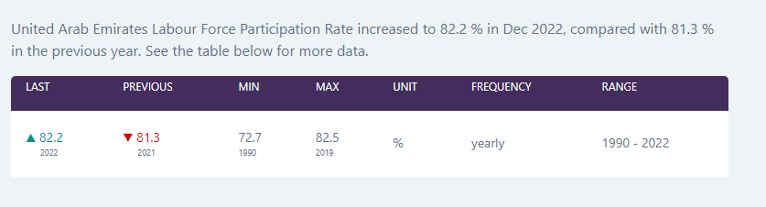

Figure 4 [https://www.ceicdata.com/en/indicator/united-arab-emirates/labour-force-participation-rate#:~:text=United%20Arab%20Emirates%20Labour%20Force%20Participation%20Rate%20increased%20to%2082.2,an%20average%20rate%20of%2076.5%20%25%20](https://www.ceicdata.com/en/indicator/united-arab-emirates/labour-force-participation-rate%23:~:text=United%20Arab%20Emirates%20Labour%20Force%20Participation%20Rate%20increased%20to%2082.2,an%20average%20rate%20of%2076.5%20%25%20).

# Networking Issues (Social Networks / Wed 2.0 / IR 4.0)

Social media marketing is essential for businesses in the UAE. The main platforms in the region are Facebook, Twitter, Instagram, LinkedIn, YouTube, Snapchat, Pinterest, and TikTok. Businesses can benefit from social media by increasing brand awareness, promoting products/services, driving traffic, engaging with consumers, addressing pain points, storytelling, collecting data, link building, and driving conversions.

Choosing the right platforms depends on goals and target audience. Facebook has a large reach, Twitter is conversational, Instagram is visual and reaches a younger audience, LinkedIn is for business networking, and YouTube has a wide reach and multilingual capabilities.

## 8.1 Review of the organisation’s presence in social networks and media

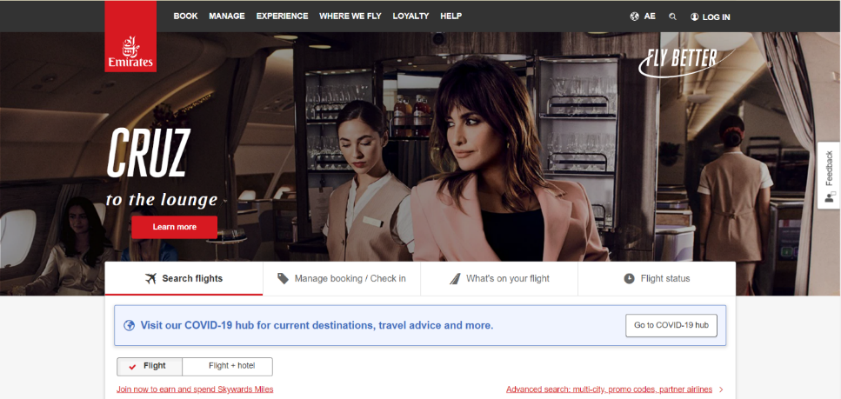

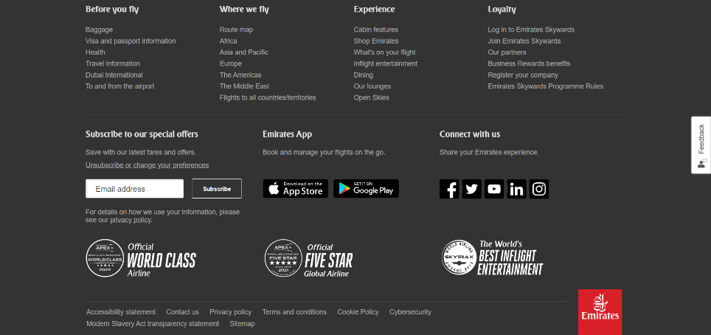

Figure 5 <https://www.emirates.com/ae/english/>

Emirates airline website provides links to social media (Facebook, LinkedIn, Instagram, Twitter, YouTube and News). Emirates social media sites are a big part of how they promote their brand by making it more visible and getting people involved. Emirates can share interesting content about their travel destinations, on-board experiences, and special deals on sites like Facebook, Instagram, and Twitter. By responding to comments and questions, they give customers personalized help and build strong relationships with their audience. Social media makes it easy for Emirates to create a sense of community, build brand loyalty, and stay in touch with their customers.

**Followers on social media of emirates:**

|  |  |
| --- | --- |
| Platforms | Followers/Subscribers/Likes |
| Facebook | 11 Million |
| Instagram | 6.8 Million |
| YouTube | 910K |
| Twitter | 1.6 Million |
| LinkedIn | 3 Million |
|  |  |
|  |  |

## 8.2 Review of the organisation’s use of the Internet for business purposes

Emirates uses the internet well for a variety of business purposes to improve customers' experiences and drive growth. Through their online booking system, customers can easily reserve flights and get access to other services, making it easy and convenient. The Internet is also a place where Emirates can help customers by answering questions and fixing problems quickly. Emirates also uses digital marketing techniques to reach a larger audience, promote their brand, and show off special deals. Online, passengers can get information and updates about their flights in real time, which helps them stay informed and ready for their trips. By looking at the data collected from online interactions, Emirates gains valuable insights that help them make strategic decisions and give customers more personalized experiences. Overall, Emirates uses the internet to its fullest potential to streamline operations, engage customers, and keep a strong online presence.

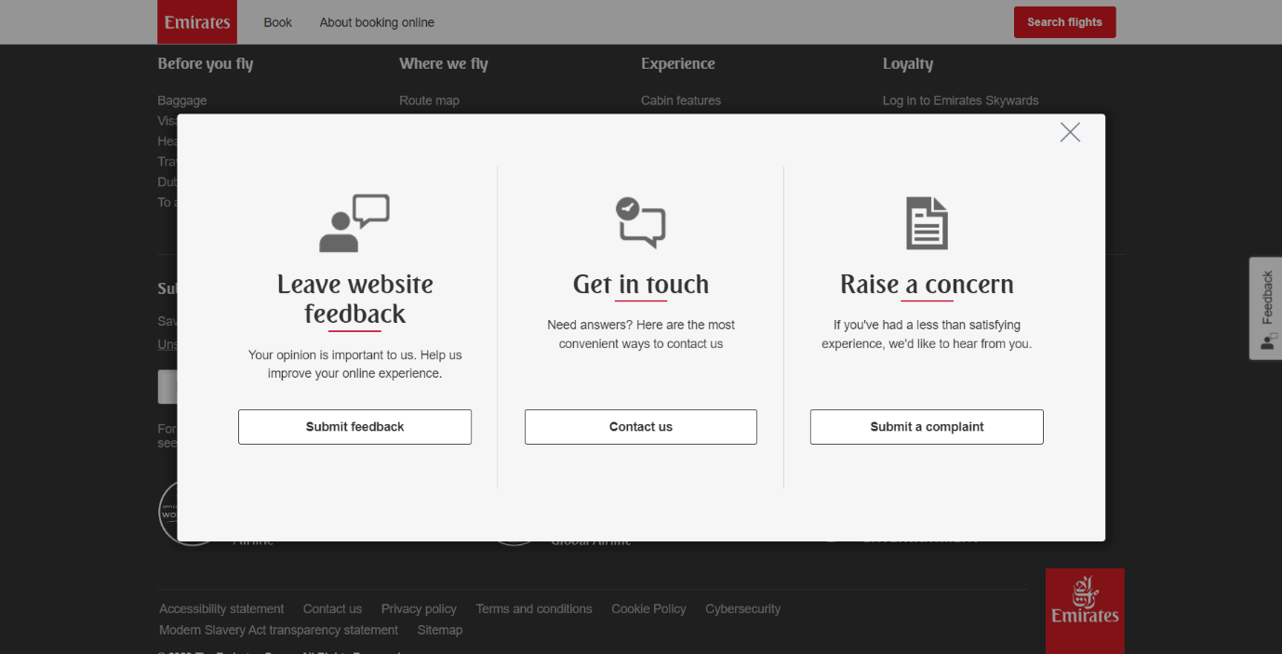

Figure 6 <https://www.emirates.com/ae/english/>

## 8.3 Review of the organisation’s practices aligned towards IR 4.0

Emirates has embraced digital technologies such as data analytics, artificial intelligence, and machine learning in order to improve operational efficiencies and provide a more personalized travel experience. They provide connectivity via Wi-Fi on-board their flights in addition to offering digital services such as online booking and mobile check-in. In addition to this, Emirates utilizes robotics and automation for a variety of tasks, including the handling of baggage and the inspection of aircraft. They have made a significant investment in fuel-efficient aircraft as well as green initiatives as part of their commitment to sustainability.

# Agile Approach to MIS

The Agile Approach to Management Information Systems (MIS) is a methodology that promotes iterative development, collaboration, and flexibility in deploying MIS solutions. It focuses on delivering incremental value to stakeholders through frequent feedback and continuous improvement. By adopting Agile principles and practices, organizations can effectively respond to changing business requirements, reduce time-to-market, enhance customer satisfaction, and achieve higher-quality MIS solutions. Agile methodologies such as Scrum, Kanban, and Lean provide frameworks for cross-functional team collaboration and efficient project management. This approach enables organizations to embrace change, improve operational efficiency, and drive innovation in the context of MIS deployment (Reference: Sharma, R., & Mishra, P. (2020).

## 9.1 Overview of agile approaches in deployment of MIS

Agile is a cutting-edge method of project management that enables developer teams to quickly and easily deliver value to their clients. The agile approach aids project managers in better planning, evolutionary development, on-time delivery, ongoing improvement, and adaptability to change (Mutabaruka, 2021). The Agile methodologies manifesto lists some fundamental principles like customer satisfaction, business collaboration, accepting change, technical excellence, good design, simplicity, etc.

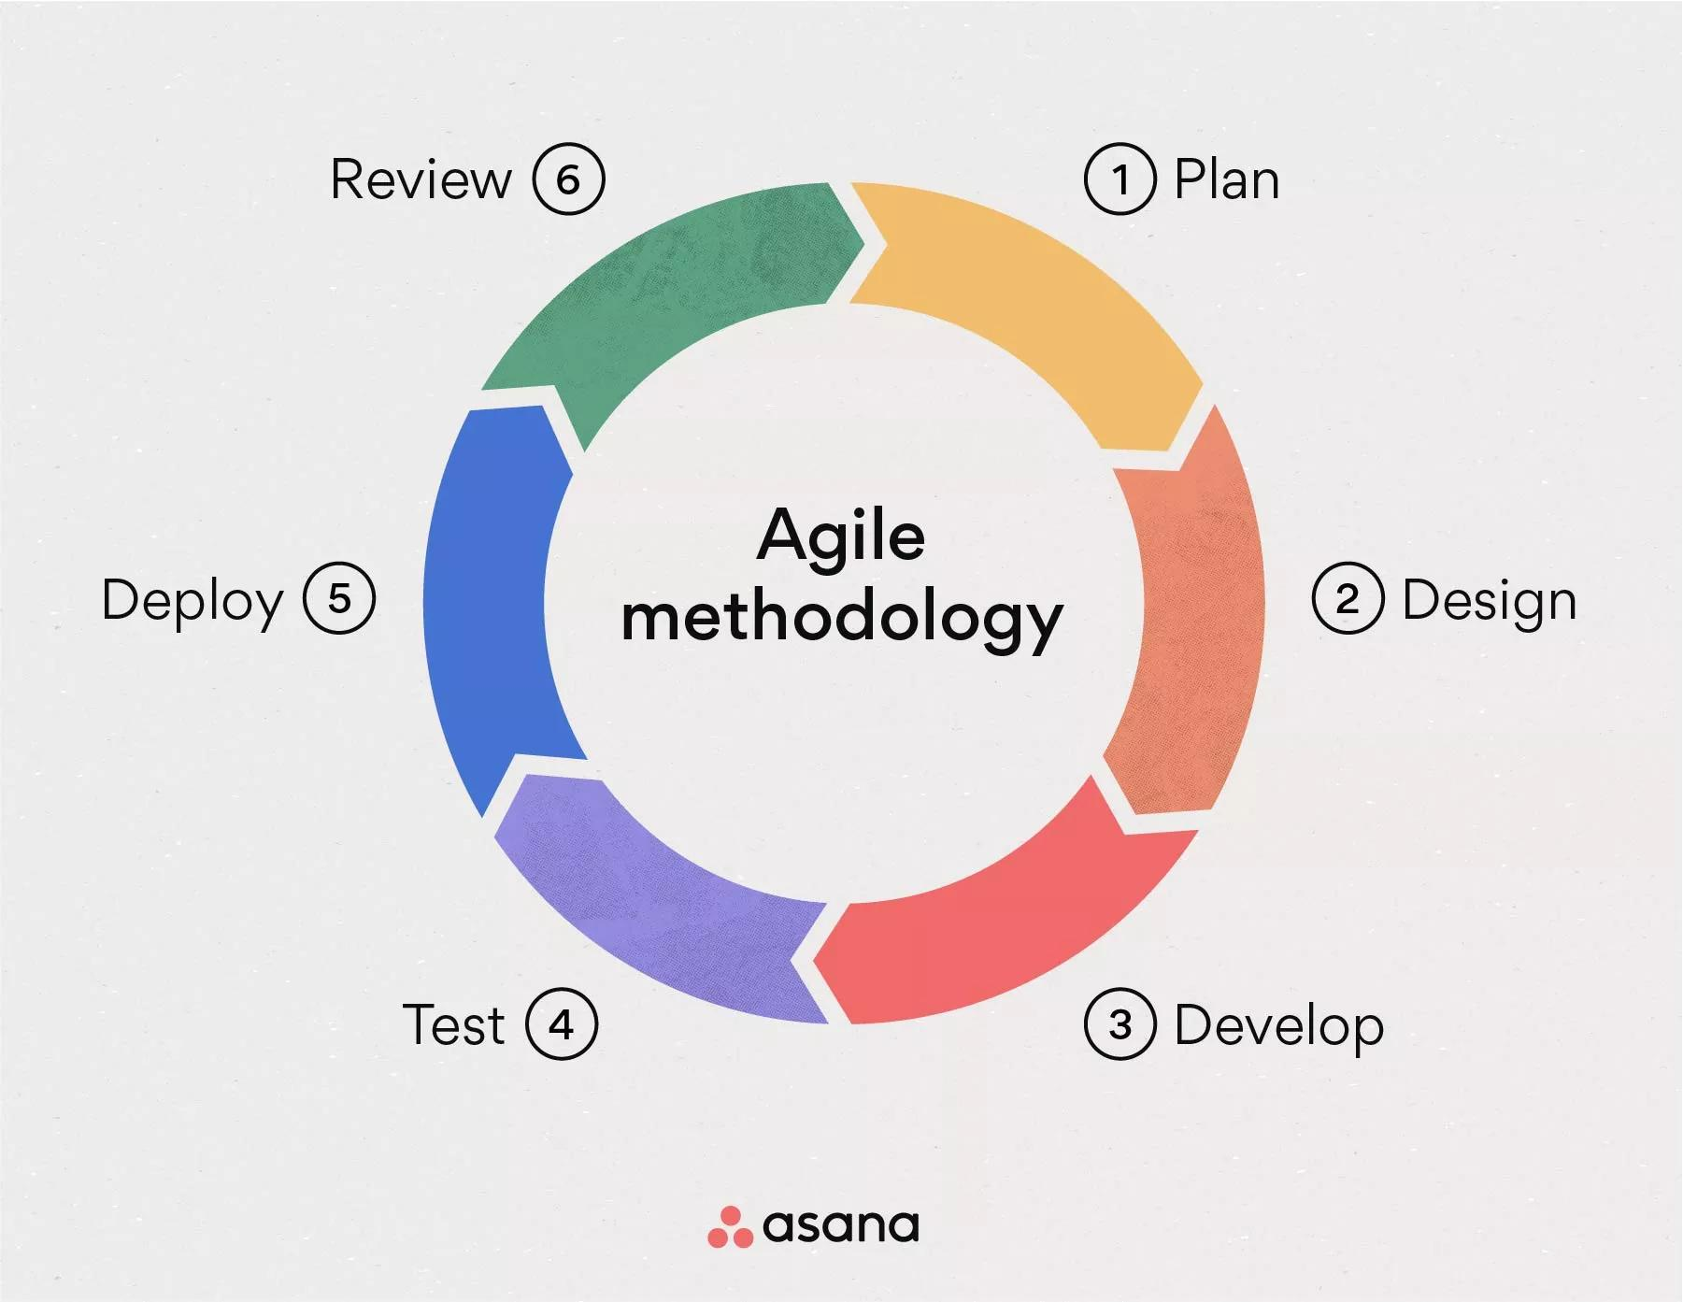

Emirates utilizes the agile process as an alternative approach to project management and long-term planning. There are various agile process models, including feature-driven development, agile modelling, scrum, adaptive software development, and dynamic systems development method. The object-oriented extreme model's primary tasks include planning, designing, coding, and testing. The scrum model is applied to complicated projects where work is done in small teams and the project is broken up into manageable pieces.

Scrum is the right framework for Emirates. Scrum is an agile project management approach with the primary objective of raising team productivity. This approach creates teams by utilizing diversity, effective communication, and regular client feedback. Emirates operates in a highly competitive industry, so the business must quickly adapt to customer feedback and maintain top-notch services. The scrum method is the best because it requires small teams to meet frequently and make changes in response to feedback (Sachdeva, 2016).

## 9.2 Introduction of an operational plan for transforming current practices

Add text here…

Note: This section relates to content covered in week 9 and in particular slides 34-42. Use the theoretical underpinnings from the lectures and apply them to your case study. Do not explain the theories and models as this is will take up too many words and is not going to offer you any extra grades.

## 9.3 Description of measurable key performance indicators for the agile MIS approach

Add text here…

Note: This section relates to content covered in week 9 and in particular slides 44-52. Use the theoretical underpinnings from the lectures and apply them to your case study. Do not explain the theories and models as this is will take up too many words and is not going to offer you any extra grades.

# Impact of Information Systems on Society (ethics / privacy / security / CSR)

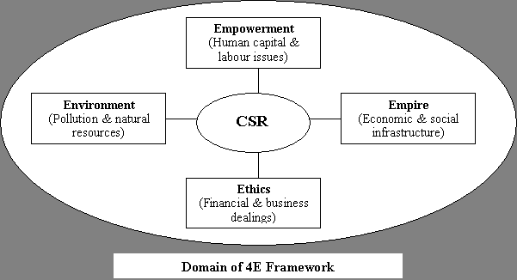

## 10.1 Reflection on the ethical impact of the organisation’s operations

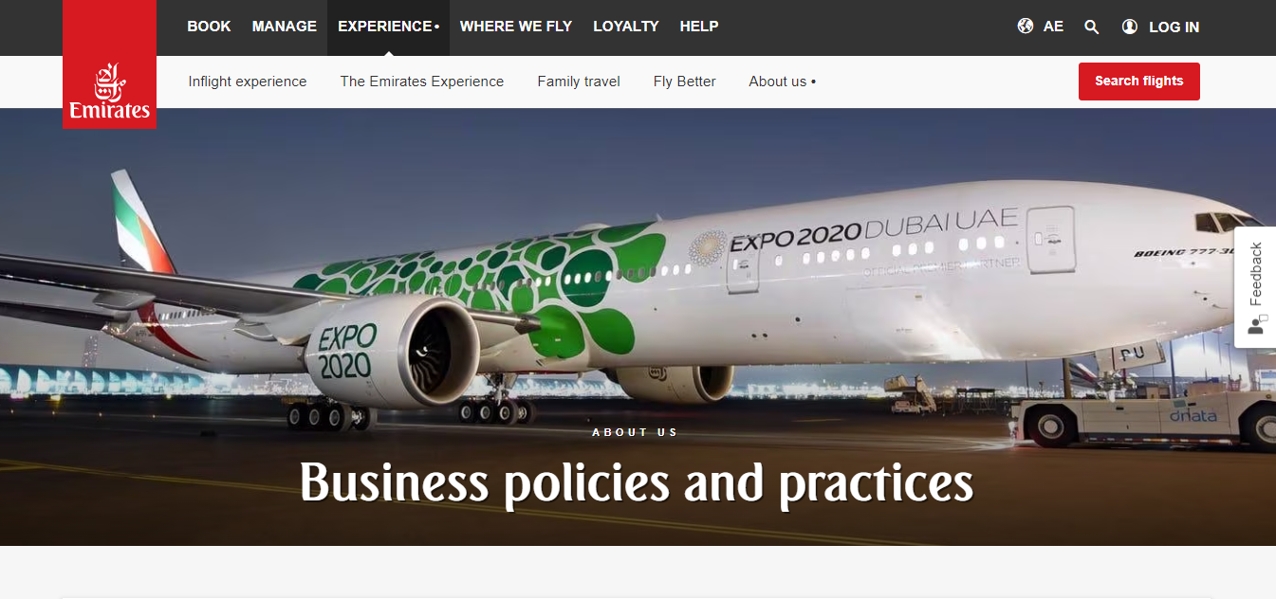

It is not possible to properly evaluate the ethical impact of Emirates airline operations based on the information supplied in the privacy policy of the Emirates Group. The privacy policy primarily focuses on how Emirates collects, uses, and manages personal data for a variety of objectives, such as service provision, marketing, and compliance with regulatory requirements. The ethical implications of airline operations go far beyond privacy issues and include a variety of things like social responsibility, labour policies, environmental sustainability, and safety requirements. Analysing additional data pertaining to these issues would be necessary to assess the ethical impact of Emirates airline operations.

It is impossible to fully evaluate Emirates' ethical impact without thorough information on its environmental procedures, staff treatment, safety records, customer happiness, and community involvement.

It's crucial to keep in mind that determining the ethical impact of a company's activities necessitates taking into account a variety of factors and performing a complete analysis that goes beyond the data contained in a privacy policy.

## 10.2 Evaluation of the organisation’s current practices towards privacy / security / safety

Emirates Group, which includes Emirates airline, demonstrates a strong commitment to privacy, security, and safety by the information provided in their privacy policy. This commitment is based on the information provided in their policy. A strong emphasis is placed on transparency, and honesty and integrity are maintained throughout the handling of personal information. Data is gathered for specific and explicable reasons, such as the provision of services, the fulfilment of legal obligations, the guaranteeing of safety, and the acquisition of customer consent for marketing communications, among other reasons. The organization is aware of the significance of maintaining data security and has implemented the necessary safeguards to protect the information of its users. Customers have the ability to access, restrict, object to, and transfer any data they have stored with the company. Data transfers that take place across international borders are safeguarded, and the privacy of individuals is maintained. Only for legitimate business purposes do we collect, use, or disclose personally identifiable information. In addition to this, they cover the proper management of sensitive data such as medical records.

## 10.3 Assessment of the organisation’s credo in relation to CSR



By addressing environmental issues and aiming for successful financial results, Emirates Airlines has demonstrated its understanding of Corporate Social Responsibility (CSR). Although specific programs aren't mentioned, it's likely that the airline works to lessen its environmental impact by reducing its carbon footprint. In addition, investments in in-flight entertainment systems show an effort to improve traveller satisfaction and customer satisfaction. Emirates Airlines could engage with a wider range of stakeholders, implement targeted measures to reduce environmental impact, and broaden its social contributions beyond in-flight amenities in order to further improve its CSR practices. These recommendations seek to coordinate the airline's CSR initiatives with stakeholder expectations, encourage sustainability, and improve societal and environmental conditions.

# Intelligence and MIS (BI / AI / IE)

Add text here…

Reminder 1: Include figures, graphs tables and any other illustrations that will enrich your discussion, either from the resources provided in the week folder or materials that you have found during your own research. By including such material, you can only refer to it and. Discuss how it applies on the case study, therefore significantly reducing the word count of the report.

Reminder 2: Make sure you reflect on your selected case study organisation and relate any discussion to specific aspects of the organisation in your role as consultants.

Reminder 3: Emphasise in your discussion aspects of MIS and avoid to focus only on business aspects. The report requires you to make suggestions how the case study organisation should embrace and exploit the technologies discussed in each section. Consider how to use the content your group uploaded on the Wiki.

## 11.1 Evaluation of the organisation’s maturity to integrate Business Intelligence

Add text here…

Note: This section relates to content covered in week 11 and in particular slides 4-17. Use the theoretical underpinnings from the lectures and apply them to your case study. Do not explain the theories and models as this is will take up too many words and is not going to offer you any extra grades.

## 11.2 Assessment of any opportunities for application of Artificial Intelligence solutions

Add text here…

Note: This section relates to content covered in week 11 and in particular slides 20-34. Use the theoretical underpinnings from the lectures and apply them to your case study. Do not explain the theories and models as this is will take up too many words and is not going to offer you any extra grades.

## 11.3 Assessment of the organisation’s capacity to exploit Intelligent Environments

Add text here…

Note: This section relates to content covered in week 11 and in particular slides 36-45. Use the theoretical underpinnings from the lectures and apply them to your case study. Do not explain the theories and models as this is will take up too many words and is not going to offer you any extra grades.

# Conclusions

Add text here…

In this section you must provide a very brief summary of a couple of lines for your report.

## 12.1 Summary of main suggestions for the organisation

Add text here…

In this section you should provide one suggestion per topic/section for your case study organisation. What should their next actions be with regards to each topic?

## 12.2 Identification of main constraints in applying proposed plans

Add text here…

In this section you should identify the main obstacles in implementing the suggestions you made in the previous sub-section.

## 12.3 Reflection on lessons learnt for the members of the start-up

Add text here…

In this section you should briefly discuss the key lessons your group learnt during the project with emphasis on those aspects you would change for your next project.

# Appendix A – Interview questions

N/A – this was included in the Group Reports

# Appendix B – Individual reflection

ATTENTION: This section is critical in order to obtain your individual portfolio grades. It should contain individual reflection statements from each group member including their contribution and personal views on the report sections. Below is an example of what is required from each member. Include the same information, following the same structure for each member.

## Member 1 – M00…… First Name, LAST NAME

Add text here…

You should provide your reflection on each of the topics covered in the report. Although you may have worked primarily on specific sections as part of your individual work you should have discussed each topic on weekly blogs. Consider how to use the content you uploaded on your blog for each of the following sections.

Topic 7 – Globalisation Issues (marketplaces / infrastructure / workforce)

Add text here… (focus on slides, articles and Individual GOALs from Week 7)

Topic 8 – Networking Issues (Social Networks / Wed 2.0 / IR 4.0)

Add text here… (focus on slides, articles and Individual GOALs from Week 8)

Topic 9 – Agile Approach to MIS

Add text here… (focus on slides, articles and Individual GOALs from Week 9)

Topic 10 – Impact of Information Systems on Society (ethics / privacy / security / CSR)

Add text here… (focus on slides, articles and Individual GOALs from Week 10)

Topic 11 – Intelligence and MIS (BI / AI / IE)

Add text here… (focus on slides, articles and Individual GOALs from Week 11)

## Member 2 – M00…… First Name, LAST NAME

Add text here…

You should provide your reflection on each of the topics covered in the report. Although you may have worked primarily on specific sections as part of your individual work you should have discussed each topic on weekly blogs. Consider how to use the content you uploaded on your blog for each of the following sections.

Topic 7 – Globalisation Issues (marketplaces / infrastructure / workforce)

Add text here… (focus on slides, articles and Individual GOALs from Week 7)

Topic 8 – Networking Issues (Social Networks / Wed 2.0 / IR 4.0)

Add text here… (focus on slides, articles and Individual GOALs from Week 8)

Topic 9 – Agile Approach to MIS

Add text here… (focus on slides, articles and Individual GOALs from Week 9)

Topic 10 – Impact of Information Systems on Society (ethics / privacy / security / CSR)

Add text here… (focus on slides, articles and Individual GOALs from Week 10)

Topic 11 – Intelligence and MIS (BI / AI / IE)

Add text here… (focus on slides, articles and Individual GOALs from Week 11)

# Appendix C – Further evidence

In this appendix you may include any additional information you wish to include in your report that will **not** be included in the word count.

# References

“Emirates Flights – Book a Flight, Browse Our Flight Offers and Explore the Emirates

Experience.” *Emirates*, 2019,  [www.emirates.com/ae/english/](http://www.emirates.com/ae/english/).

Emirates. “About Us | Emirates United Arab Emirates.”

*Emirates United Arab Emirates*, 2019, [www.emirates.com/ae/english/about-us/](http://www.emirates.com/ae/english/about-us/).

“Privacy Policy | Emirates Website Policy and Information | Emirates United Arab

Emirates.” United Arab Emirates,

[www.emirates.com/ae/english/information/privacy-policy/](http://www.emirates.com/ae/english/information/privacy-policy/).

“Emirates Airlines CSR Application - 5315 Words | Research Paper Example.”

Free Essays, [ivypanda.com/essays/emirates-airlines-csr-application/.](ivypanda.com/essays/emirates-airlines-csr-application/)

“Contact Emirates about Security Issues | Emirates United Arab Emirates.” United

Arab Emirates, [www.emirates.com/ae/english/information/cybersecurity/.](http://www.emirates.com/ae/english/information/cybersecurity/)

“Emirates Flights – Book a Flight, Browse Our Flight Offers and Explore the Emirates

Experience.” *Emirates*, 2019, [www.emirates.com/ae/english/](http://www.emirates.com/ae/english/).

Emirates. “About Us | Emirates United Arab Emirates.”

*Emirates United Arab Emirates*, 2019, [www.emirates.com/ae/english/about-us/](http://www.emirates.com/ae/english/about-us/).

India, legal S. (no date) Impact of information technology on corporate social responsibility,

Legal Service India. Available at: <https://www.legalserviceindia.com/articles/info_law.htm>

(Accessed: 29 June 2023).

Issues brief - globalization: A brief overview (no date) International Monetary Fund. Available

at: https://www.imf.org/external/np/exr/ib/2008/053008.htm (Accessed: 29 June 2023).

The Emirates success story. (2015). The First Group.

The Emirates success story. (2015). The First Group.

<https://www.thefirstgroup.com/en/news/the-emirates-success-story/>

The Emirates Success Story (no date) The First Group. Available at: [https://www.thefirstgroup.com/en/news/the-emirates-success-story/#:~:text=Emirates’%20rapid%20growth%20has%20reflected,least%2070%20million%20passengers%20annually](https://www.thefirstgroup.com/en/news/the-emirates-success-story/%23:~:text=Emirates’%20rapid%20growth%20has%20reflected,least%2070%20million%20passengers%20annually).

(Accessed: 29 June 2023).